Publisher | Editors

HEWI
Marketing + Innovation

HEWI Heinrich Wilke GmbH
PO Box 1260
D-34442 Bad Arolsen
Phone: +49 5691 82-0
presse@hewi.de
www.hewi.com

Clara Brenneker
Phone: +49 5691 82-214
cbrenneker@hewi.de

Nicolo Martin
Phone: +49 5691 82-106
nmartin@hewi.de

Reprint free of charge - copy requested

Accessories
System 900
System 900 offers a coherent overall concept for the high-quality hotel bathroom or your own four walls. System 900 is convincing in a wide variety of application areas and property types. Numerous awards prove that System 900 is the answer to the complex requirements of barrier-free bathrooms.
The sophistication of a concept is evident in the planning details. System 900 combines functionality as well as excellent design with durable, sustainable quality and thus creates added value.
New accessories have been added to the range with immediate effect. Practical toilet paper holders with lids or trays, new towel holders or toilet brush sets matching System 900 are available in stainless steel, chrome and powder-coated versions in white, grey tones and black.
Universal Products
In addition, a wide range of universal products from waste bins, vanity mirrors and towel racks to hairdryers and hand showers allow you to equip your bathroom from a single source.

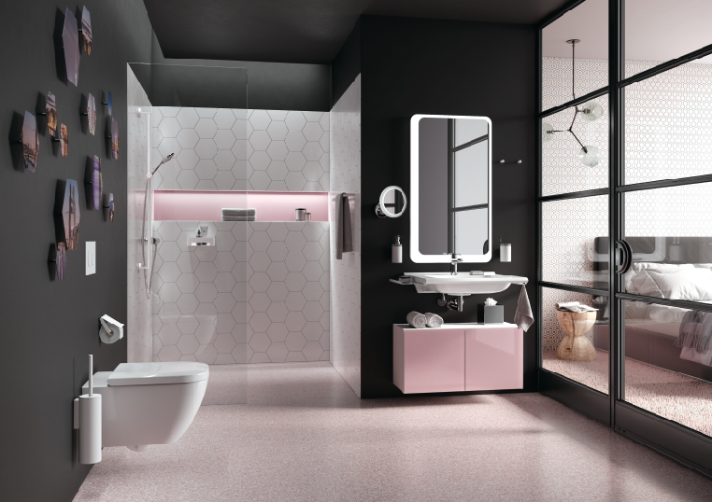
System 900: A coherent overall concept from a single source

HEWI | Hotel

Reduction to the essentials is the design principle that corresponds to all HEWI systems. The high-quality accessories for the washbasin, shower and WC areas in minimalist design blend perfectly into any hotel bathroom.
Diverse materials and differentiated designs offer countless design options. In addition to accessories, the range also includes solutions for barrier-free furnishing and fittings.

