Publisher | Editors

HEWI
Marketing + Innovation

HEWI Heinrich Wilke GmbH
PO Box 1260
D-34442 Bad Arolsen
Phone: +49 5691 82-0
presse@hewi.de
www.hewi.com

Reprint free of charge - copy requested

ENTRO handrail systems
Modular product solutions
The modular solutions for the areas of handrails, wall protection and signage are perfectly coordinated. The modular principle enables a wide range of combination options. This makes it possible to realise solutions that are precisely tailored to individual requirements. The products convince with their high functionality, certified quality and clear design language. Design options are possible due to the formally coordinated systems, diverse materials (polyamide, stainless steel, wood) and differentiated designs.
The variety of materials is now even greater - System lignum is now also available in bamboo. The wooden handrail systems are made exclusively from woods that come from ecological cultivation. New supports allow further material and design options so that the attachment of the handrails is perfectly matched to the local conditions.
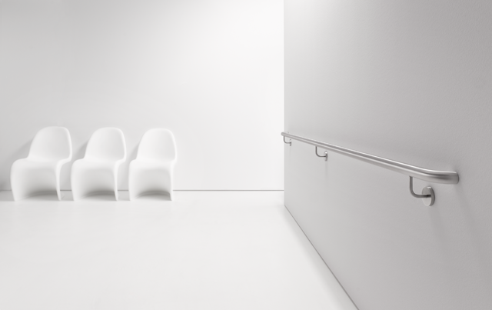

ENTRO handrail system circum

For more information, please contact:

HEWI Heinrich Wilke GmbH
PO Box 12 60
D-34442 Bad Arolsen
Phone +49 5691 82-0
E-mail: presse@hewi.de
Internet: www.hewi.com

