Publisher | Editors

HEWI
Marketing + Innovation

HEWI Heinrich Wilke GmbH
PO Box 1260
D-34442 Bad Arolsen
Phone: +49 5691 82-0
presse@hewi.de
www.hewi.com

Clara Brenneker
Phone: +49 5691 82-214
cbrenneker@hewi.de

Nicolo Martin
Phone: +49 5691 82-106
nmartin@hewi.de

Reprint free of charge - copy requested

H4 Hotel Mönchengladbach

In the newly built H4 Hotel directly at the stadium of the first division football team Borussia Mönchengladbach, the hearts of the Fohlen fans beat faster.
Included: The lever handle 162 in robust stainless steel - quality and attractive design in one.

Borussia Park Mönchengladbach

The proximity to the football pitch of Borussia Mönchengladbach influences the design of the rooms of the H4 Hotel and the building.
The individual rooms reflect the action on the pitch. Each floor has its own individual design and shows great football moments in the club's history. Themed rooms on the floors offer insights into Champions League, European Cup, DFB Cup and championship successes. In some rooms, the guest stays overnight with a view of the pitch from the bed. This makes the overnight stay a unique experience for the fan.

But this hotel is more: With a total area of around 15,000 m² and seven floors, the building not only houses the H4 Hotels brand hotel with 131 rooms and other hotel facilities. The building also houses the club museum, the fan shop, rehabilitation and fitness centre with treatment rooms, and the club's administration. The fan cannot stay closer to his club.
Even the design of the building is closely related to the Borussia Mönchengladbach club. The club crest - the Borussia rhombus - is the design principle.

"With the H4 Hotel Mönchengladbach, we have created a place where football enthusiasts can follow the sporting action up close," says Alexander Fitz, CEO of H-Hotels AG. "A lot of heart and soul has gone into this project. We hope that the guests will enjoy it as much as we do. Both the location and the concept of the hotel promise an impressive stay."

Slapa Oberholz Pszczulny | Architects

The architects J.M. Slapa, H. Oberholz and Z. Pszczulny have been jointly developing and realising buildings in the areas of office, commercial, hotel, industrial and residential construction as well as airports, sports facilities or facilities for teaching and research for over 30 years.
The internationally active architectural practice sop architekten, with around 90 employees and headquarters in Düsseldorf, stands for a clear, timeless architectural language and for the holistic consideration of a building down to the last detail.
The architectural principle is not short-term effect or flashiness at any price. The architectural practice focuses on timeless architecture, clearly structured and designed for the long term. A building must be just as present and appropriate, coherent and comprehensible in 30 years as it is today.

System 162 - Design and quality

The lever handle series 162 from HEWI blends in with the avant-garde architectural style of the H4 Hotel at Borussia Park. The elegant but robust style of this hardware series creates an extremely appealing effect on the door. The purist design solution of lever handle 162 in the mini version reduces the lever handle to the essentials without sacrificing functionality. Even in the free-occupied version, it creates a sophisticated impression in the hotel bathroom.

The design language of System 162 is based on the mitre cut. In the 1920s, the French architect Robert Mallet-Stevens came up with the idea of separating a round tube and rejoining it at right angles with a mitre cut. He thus created a minimalist lever handle for timeless architecture. Today, the design is best known as the "Frankfurt lever handle". The purist design concept of System 162 convinces with its straightforward design, high functionality and material options.

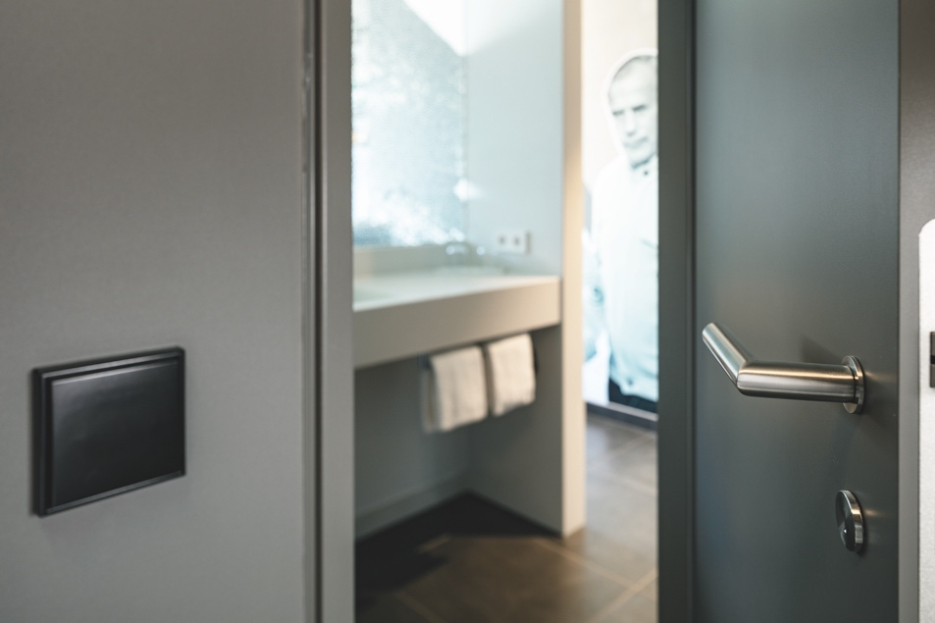

The lever handle 162 in robust stainless steel

Photographer: Thomas Ott

