Publisher | Editors

HEWI
Marketing + Innovation

HEWI Heinrich Wilke GmbH
PO Box 1260
D-34442 Bad Arolsen
Phone: +49 5691 82-0
presse@hewi.de
www.hewi.com

Reprint free of charge - copy requested

Secure support
Holding and support folding handles
The balance between pragmatic and emotional aspects is crucial in the design of accessible products. Products that enable simple, comfortable and above all flexible use fulfil this requirement.
Handholds
Grab rails provide safety and support in all areas of the sanitary room - whether at the washbasin, WC or shower. Grip surfaces and cross-sections that are adapted to the hand enable dynamic gripping and effective force transmission. HEWI grab rails allow simple, comfortable and above all flexible use. Filigree supports and extremely flat rosettes emphasise the reduced design. A wide range of materials offers design options.
Folding support handles
A folding support handle provides support for limited strength and mobility. An ergonomically designed, flat grip level enables a secure hold. Due to their dimensions, HEWI folding support rails are easy to grip. The front end of the handle can be easily grasped by hand so that it is easy to support oneself or pull oneself up. The folding support rail can be supplemented with comfort elements, such as an upgrade kit for a toilet roll holder or an arm pad for a particularly comfortable support. The folding support rails can be folded up against the wall to save space. Fixed support handles are also available. The Duo folding support rail also has a round lower rail to provide optimum support when turning sideways onto the toilet. The folding support rails and grab rails are available in high-gloss chrome, satin stainless steel, polyamide or as a WARM TOUCH version.
Mobile folding support handles
The portfolio has been supplemented with folding support handles that can be used individually and flexibly. If required, the portable folding support rail is simply snapped into the permanently installed mounting plate. If the folding support rail is not needed, the plate can be covered with a cover cap that matches the surface of the folding support rail.
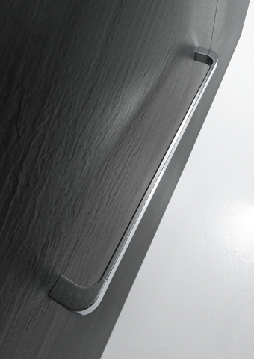
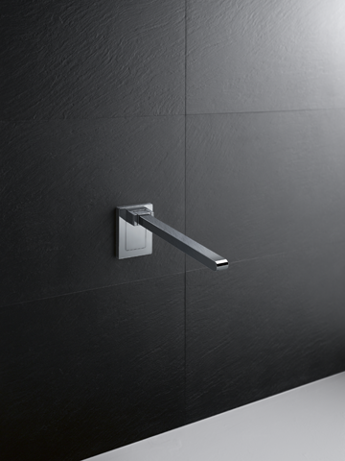
HEWI grab rail HEWI folding support rail

For more information, please contact:

HEWI Heinrich Wilke GmbH
PO Box 12 60
D-34442 Bad Arolsen
Phone +49 5691 82-0
E-mail: presse@hewi.de
Internet: www.hewi.com

