Publisher | Editors

HEWI
Marketing + Innovation

HEWI Heinrich Wilke GmbH
PO Box 1260
D-34442 Bad Arolsen
Phone: +49 5691 82-0
presse@hewi.de
www.hewi.com

Reprint free of charge - copy requested

Useful accessories
Light mirror and shower stool
Useful accessories, such as LED mirrors and shower stools, allow even more comfort in the bathroom.
LED mirror - Uniform illumination
The illuminated mirrors have LED lighting all around. The continuous LEDs are arranged behind the satinised mirror edge. They provide uniform, glare-free illumination of the face. Warm white light ensures a sense of well-being. The light source used enables realistic colour rendering. Different shapes are available: a soft-edge mirror (1000 x 570 mm), a round mirror (diameter 700 mm) and a rectangular version (680 x 600 mm).
Shower stool - safety and comfort
As mobile seating, the shower stools can be used wherever they are needed. They can be used flexibly in the bathroom - for example, also at the washbasin.
The shower stools are designed to fit perfectly into the bathroom ambience thanks to their reduced design. The stools provide support and safety when showering. They can bear a load of up to 150 kg. The pleasant surface has a fine structure so that slipping is prevented when wet.
On the one hand, a stool with an ergonomically curved seat is available. The generously designed seat is available in anthracite grey and white. The filigree frame is made of high-quality, chromed metal in a round tube design. In addition, this model has integrated holding options that support sitting down and standing up. The shower stool has a raised seat height of 50 cm, which makes sitting down and standing up even easier.
On the other hand, a shower stool made of continuous Plexiglas is available. Due to its construction, the stool has a high degree of stability - even in a wet shower. The seat height is 45 cm. The shower stool is available in matt white.
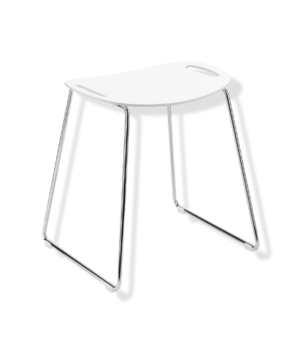

LED mirror Shower stool

For more information, please contact:

HEWI Heinrich Wilke GmbH
PO Box 12 60
D-34442 Bad Arolsen
Phone +49 5691 82-0
E-mail: presse@hewi.de
Internet: www.hewi.com

