Publisher | Editors

HEWI
Marketing + Innovation

HEWI Heinrich Wilke GmbH
PO Box 1260
D-34442 Bad Arolsen
Phone: +49 5691 82-0
presse@hewi.de
www.hewi.com

Reprint free of charge - copy requested

Custom washbasins
Design freedom due to individual lengths
The washbasins made of high-quality mineral casting convince with aesthetic and ergonomic design. They meet the highest requirements for load-bearing capacity and hygiene. In addition, their shape means that they can be moved underneath. This provides maximum comfort through barrier-free design. HEWI offers two washbasin models, the length of which can be individually determined.
The basic model has an unchangeable depth of 415 mm and a minimum width of 850 mm. The washbasin can be widened to a total length of up to 2800 mm. Asymmetrical designs are possible. In addition, HEWI offers a washbasin solution that meets the requirements of DIN 18040 due to a depth of 550 mm.
The models have an oval basin and front-mounted grab bars, which can also be used as towel rails. With the washbasins made to measure, custom-fit solutions can be realized. The production is accurate to the millimeter, so that the washbasins can be perfectly inserted into the sanitary room.

Design: Phoenix Design, Stuttgart//Suzhou
Awards: Nomination for the Innovation Award for Geriatric Care 2013,
red dot award: product design 2014

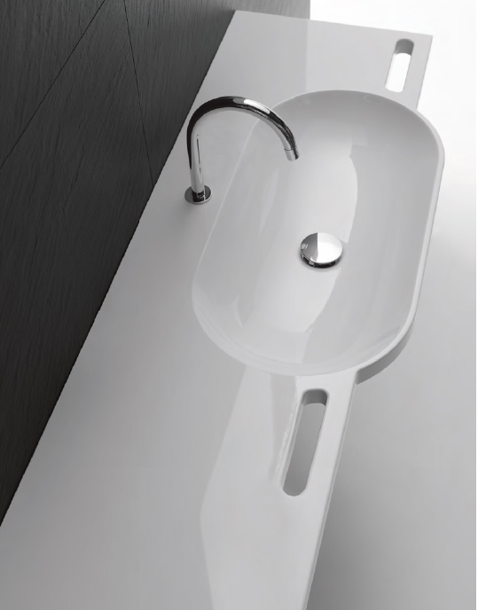

Custom washbasin

For more information, contact:

HEWI Heinrich Wilke GmbH
PO Box 12 60
D-34442 Bad Arolsen
Phone +49 5691 82-0
E-mail: presse@hewi.de
Internet: www.hewi.com

