Publisher | Editors

HEWI
Marketing + Innovation

HEWI Heinrich Wilke GmbH
PO Box 1260
D-34442 Bad Arolsen
Phone: +49 5691 82-0
presse@hewi.de
www.hewi.com

Reprint free of charge - copy requested

Series guide
Diverse signage
With clear, internationally understandable pictograms, the guide signage series conveys information and thus facilitates orientation in the building. The signage series can be used in a variety of ways. The pictograms used were designed by Otl Aicher. The signage series includes a large selection of pictograms.
Individual labelling options
With guide, a detailed guidance and orientation system can be realised. The symbols of the signage are tactile. It is also possible to apply Braille and profile lettering. Signs in tactile lettering make an important contribution to enabling people with sensory impairments to find their way around the building and thus guarantee their independence. Profile lettering can be perceived both haptically and visually. The letters and characters are displayed in a prism-like plastic form and can thus be felt and read. A clearly contrasting design is possible through font size and suitable colour selection.

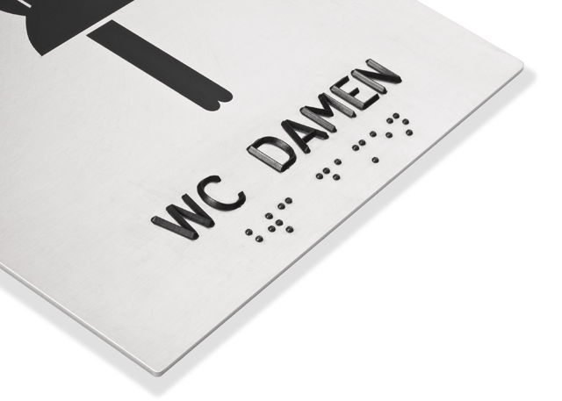

Series guide made of stainless steel with tactile help (Braille and profile writing)

For more information, please contact:

HEWI Heinrich Wilke GmbH
PO Box 12 60
D-34442 Bad Arolsen
Phone +49 5691 82-0
E-mail: presse@hewi.de
Internet: www.hewi.com

