Publisher | Editors

HEWI
Marketing + Innovation

HEWI Heinrich Wilke GmbH
PO Box 1260
D-34442 Bad Arolsen
Phone: +49 5691 82-0
presse@hewi.de
www.hewi.com

Reprint free of charge - copy requested

Series 805 Classic
Safe and robust
Series 805 Classic increases the safety of users. The barrier-free products for WC and shower are designed to reliably support users. Due to the classic round tube design, Series 805 Classic is characterised by high ergonomics and securely gripping holding systems.
Series 805 Classic shower and bath handrails, angle handles, shower support rails and shower curtain rails are available in standard dimensions or custom-made to the millimetre.
The products are extremely resilient. Series 805 Classic is made of satin stainless steel. The material impresses with its robustness and features an easy-care, hygienic surface.
Series 805 Classic products provide reliable support for limited strength and mobility. The upgrade kits increase the functionality of the stainless steel series and thus also the user comfort.
For example, folding support handles on the WC can be supplemented with a back support. This has an upholstered backrest made of easy-care, hygienic PUR. It stabilises and provides secure support for the back. HEWI folding support handles can also be supplemented with useful comfort elements, such as flush release or WC paper roll holder. The uncompromising, user-friendly design allows flexible use and promotes independence.

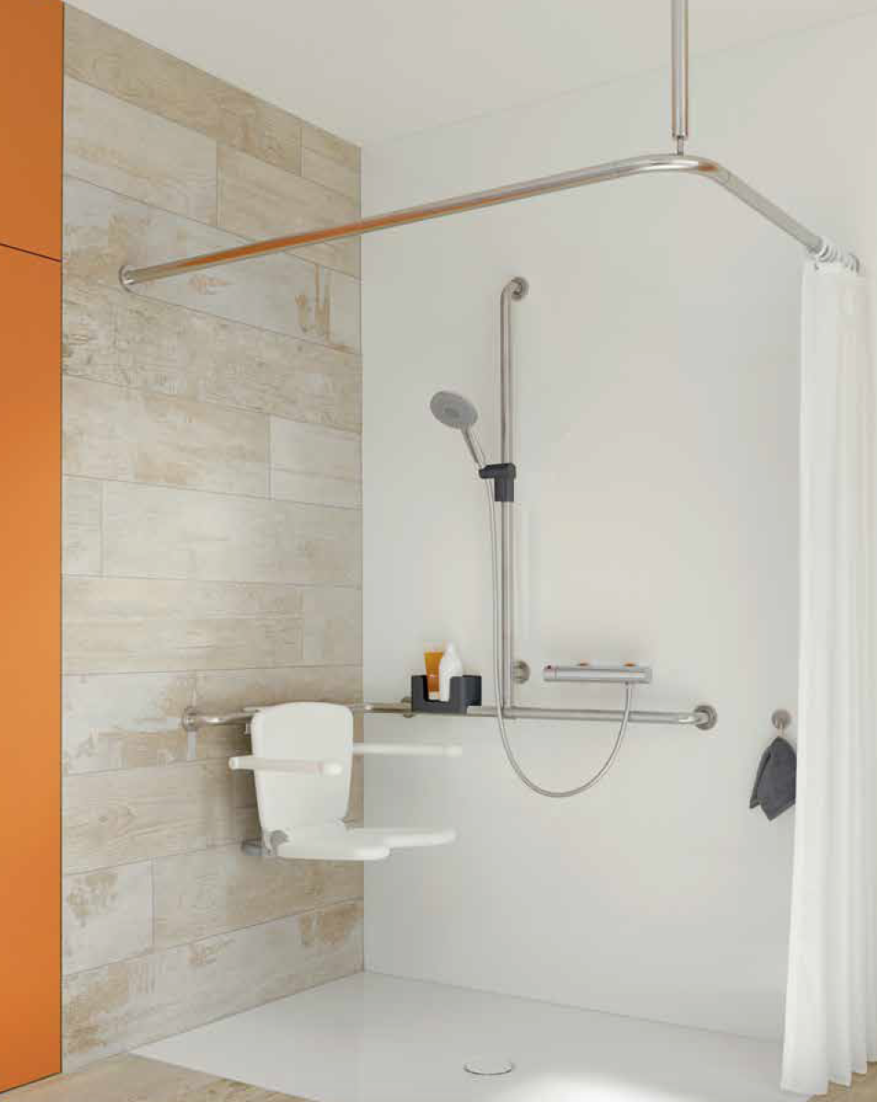

Series 805 Classic

For more information, please contact:

HEWI Heinrich Wilke GmbH
PO Box 12 60
D-34442 Bad Arolsen
Phone +49 5691 82-0
Email: presse@hewi.de
Internet: www.hewi.com

